**BUG REPORT OF TRADEMARKIA (LEGALFORCE)**

S No: **1**

**TITLE: LOGIN FAILED.**

**TYPE: FUNCTIONALITY BUG**

**DESCRIPTION:**

Account creation failed after entering the Name, Mail-id, Password.

**STEPS FOR EXECUTING:**

1.Go to the Trademarkia website.

2.Click on “LOGIN” at the right side top corner.

3.Click “CREATING A NEW ACCOUNT”.

4.Enter the Name, Mail-id, Password, Confirm Password.

5.Now click “CREATE ACCOUNT”.

**EXPECTED OUTPUT:**

Account should be created after entering the credentials.

**ACTUAL OUTPUT:**

A pop-up showing “invalid params”.

**PRIORITY:** P0

**SCREENSHOT:**

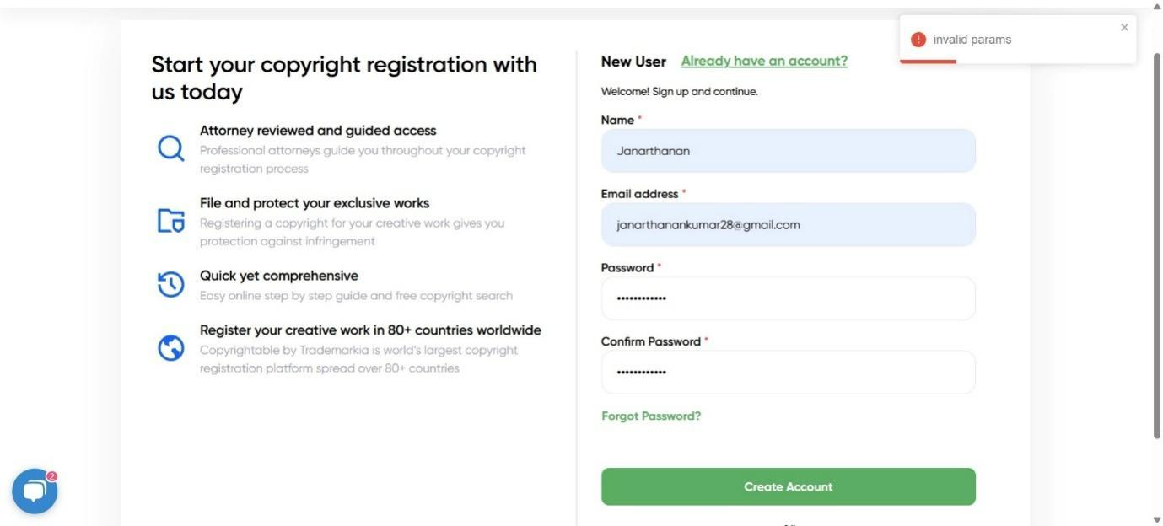

**VIDEO LINK OF THE SCREENSHOT**: [video](https://jam.dev/c/fa4d1bd8-e795-4dcb-9b67-6ebceeb268a0)

S No:**2**

**TITLE: CONTINUE WITH GOOGLE**

**TYPE: FUNCTIONALITY BUG**

**DESCRIPTION:**

**“CONTINUE WITH GOOGLE”** option does not work in the Account creation page.

**STEPS FOR EXECUTING:**

1.Go to the Trademarkia website.

2.Click on “**LOGIN**” at the right-side top corner.

3.Click “**Continue with google**” option at the bottom of the login page.

**EXPECTED OUTPUT:**

After clicking “Continue with Google” a pop-up arises showing your respected account, after clicking your account you are logged-in for this website.

**ACTUAL OUTPUT:**

A pop-up arises after clicking “continue with google” and then disappears (<1 second).

**PRIORITY:** P0

**SCREENSHOT:**

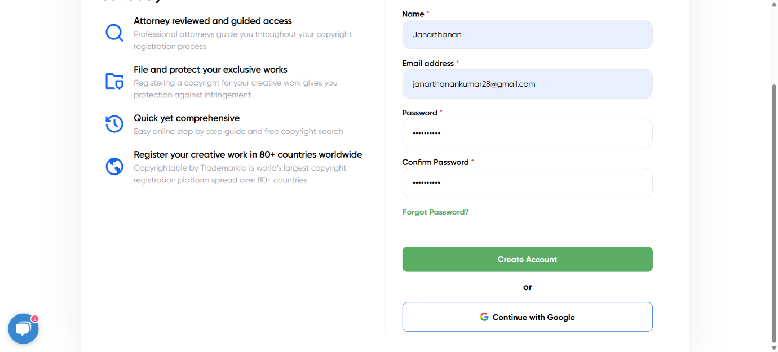

**VIDEO LINK OF THE SCREENSHOT**: [Video](https://jam.dev/c/9dd0cc44-751c-4ea9-9c01-cf1319e8db9a)

S No: **3**

**TITLE: FREQUENTLY ASKED QUESTION (AI).**

**TYPE: USABILITY BUG**

**DESCRIPTION:**

The website’s frequently asked question (Ai) does not reply to new messages rather than it’s own built questions.

**STEPS FOR EXECUTING:**

1.Go to the Trademarkia website.

2.In that you can see “about us ” option in the “support” option click that.

3.You can see **FAQ** option after the **who we are** click it.

4.Type “what Is Trademarkia” and click “**ASK LEGEND AI**” after to it.

5.Again the message will go to bottom and click up arrow (Enter) next to it.

**EXPECTED OUTPUT:**

After clicking Enter the relevant msg should be displayed related to the question.

**ACTUAL OUTPUT:**

“I'm sorry, but I couldn't generate a response for your query. Please try rephrasing or ask another question. You might find what you're looking for in our Frequently Asked Questions (FAQ) section. Please use the search bar with relevant keywords to explore the FAQ. If you still need assistance, feel free to ask again!”

The Ai is not replying with the proper Answer.

**PRIORITY:** P1

**SCREENSHOT: 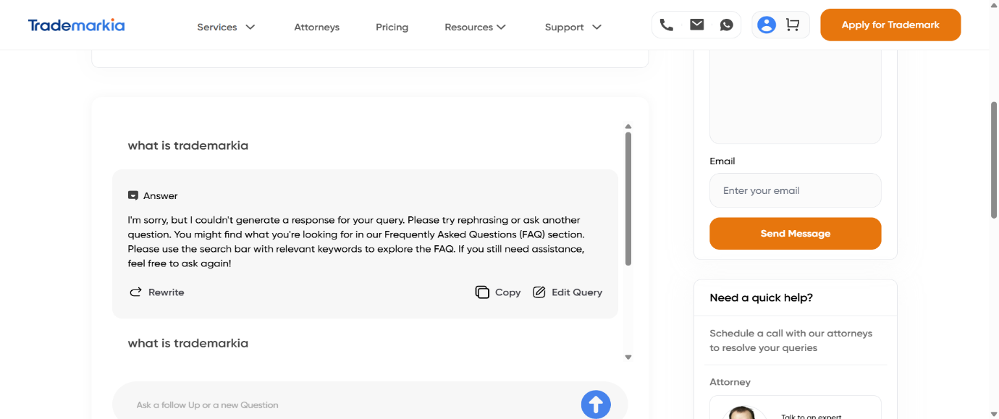VIDEO LINK OF THE SCREENSHOT:** [**video**](https://jam.dev/c/0699526f-1f83-4a5b-8105-12844bbf2ec8)

S No: **4**

**TITLE: IMAGE MISSING (HOME PAGE)**

**TYPE: FUNCTIONALITY BUG**

**DESCRIPTION:**

The image appears on desktop but missing in mobile.

**STEPS FOR EXECUTING:**

**1.**Go to the Trademarkia website.

2.when you scroll down at “**copyright your work**” you can see the image present on right side.

3.Observe the image present on desktop and missing in mobile.

**EXPECTED OUTPUT:**

The image should visible on all Screen.

**ACTUAL OUTPUT:**

The image is visible on desktop not on mobile.

**PRIORITY:** P3

**SCREENSHOT:** IN DESKTOP:

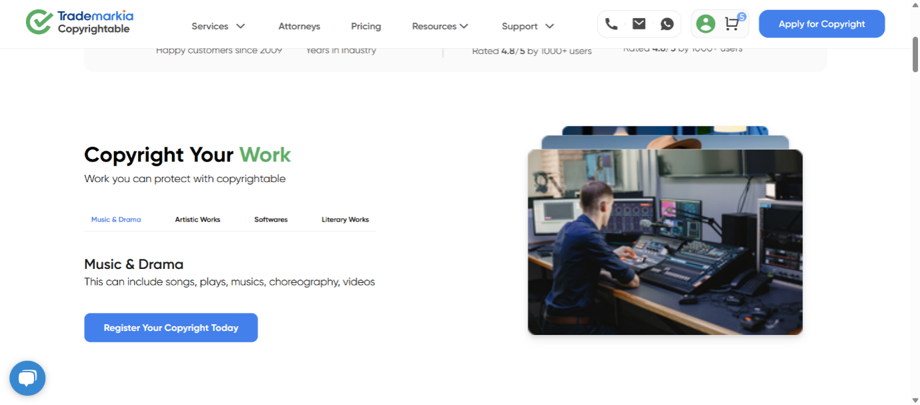

IN MOBILE:



**VIDEO LINK OF THE SCREENSHOT (DESKTOP) :**[**Video**](https://jam.dev/c/f71c63b2-c220-4f1b-ad1b-8229deaeb33a)

S NO: **5**

**TITLE: PRICING BUTTON FAILED (TAB + ENTER).**

**TYPE: ACCESSIBILITY BUG**

**DESCRIPTION:**

The "Pricing" button is not operable using keyboard (Tab + Enter).

**STEPS FOR EXECUTING:**

1.Open Trademarkia website.

2.Navigate all buttons using **TAB+ENTER.**

**EXPECTED OUTPUT:**

After doing this every button should work without failure.

**ACTUAL OUTPUT:**

The “**pricing**” button failed to navigate after clicking “Enter”.

**PRIORITY:** P1.

**SCREENSHOT:**

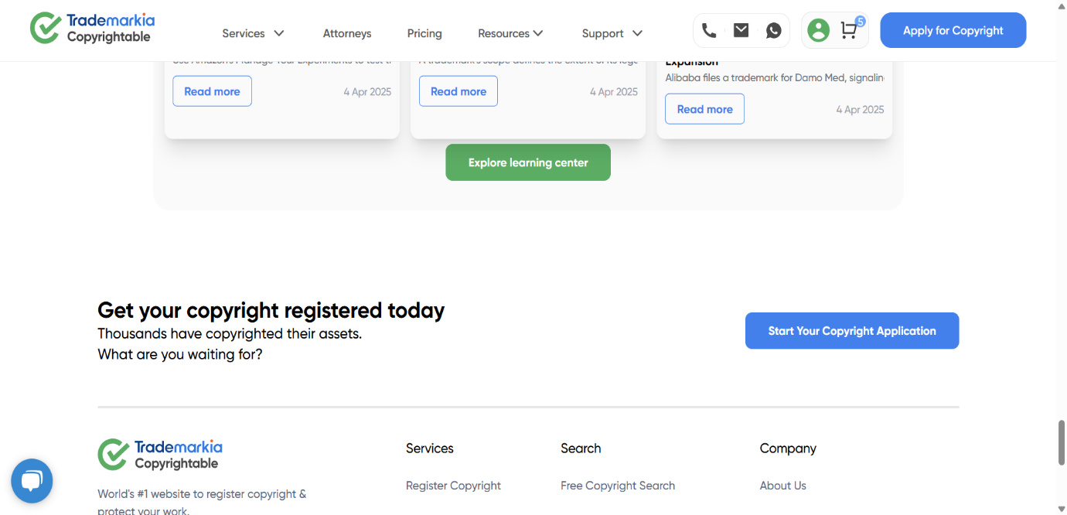

**VIDEO LINK OF THE SCREENSHOT:** [**Video**](https://jam.dev/c/f4a949b6-b064-477e-b5b6-e6368ba376cd)